# Google sheets

## Intermediate Google Sheets

### Cell addresses

* Summary:

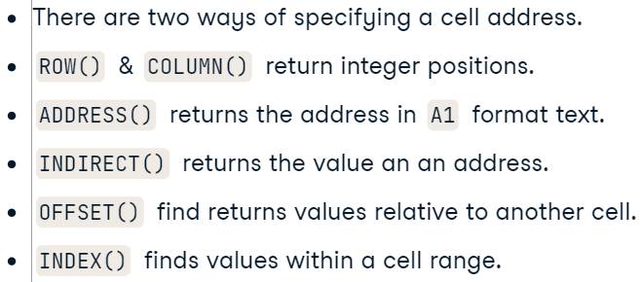

* VLOOKUP:



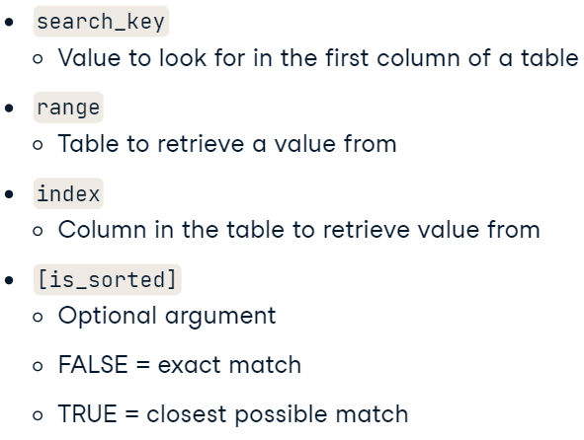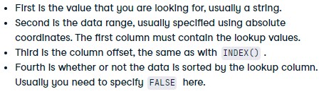

* Sorting:



* + Multiple sorting:

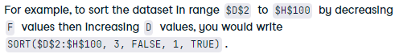

* Matching:



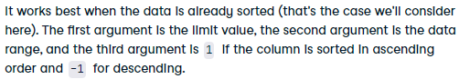

* COUNTIFS:

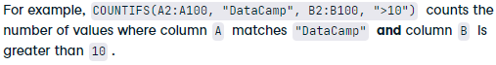

* Summary:

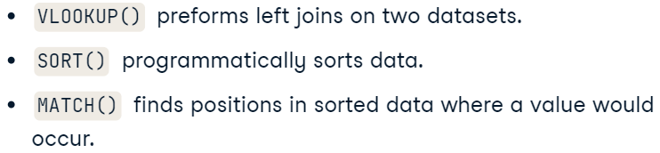

## Business Intelligence and Using Dashboards

* Questings whe creating dashboards:

1. What information are you trying to get across?
2. Who is your audience?
3. Are they viewing the information on a big screen, a desktop, laptop, tablet, or mobile phone?
4. What visualization best displays your data?

* And what else matters?

1. Do you need a logo?
2. Will you show different scenarios?
3. What about company colors?
4. Will your audience print in color or view on-screen?
5. What about 3D objects?
   1. Sometimes these can just confuse the message.
6. Consider how much detail you want.
   1. The detail shown should only be the data you need.
7. What charts do you want?
   1. Your charts are visual and should grab your reader's attention, so it is vital that you select the right chart for the right job.

### Setting up a basic dashboard

* Formulas of reference:

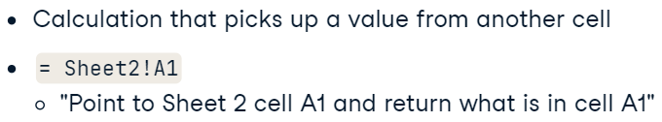

* = 'Shark Attacks'!A1

## Efficient Column Charts

### Efficient column charts

* Tables and lists:

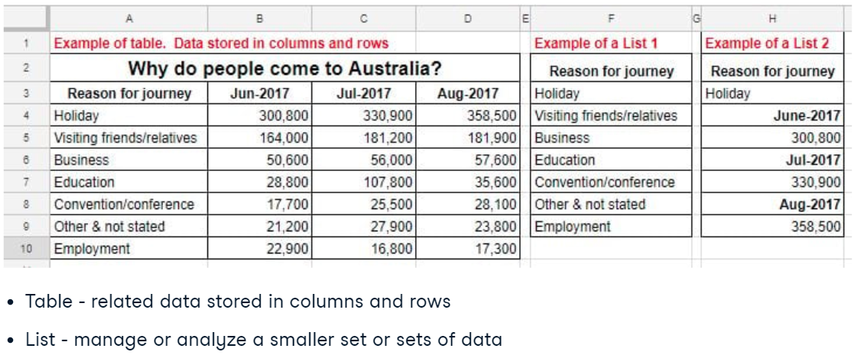

### Named ranges

* What is it (Cntl_J):

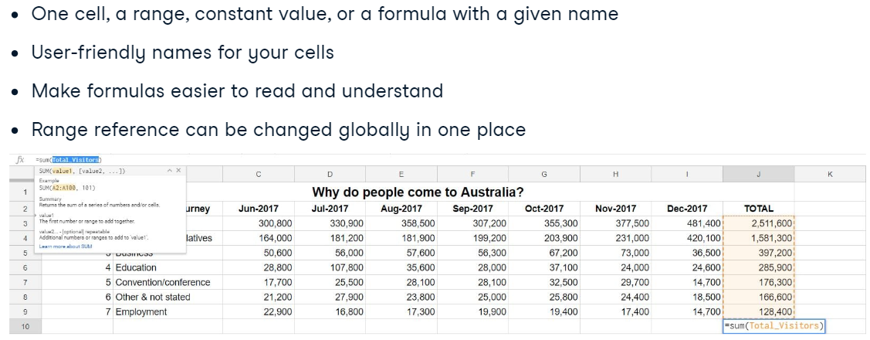

* How to create it:

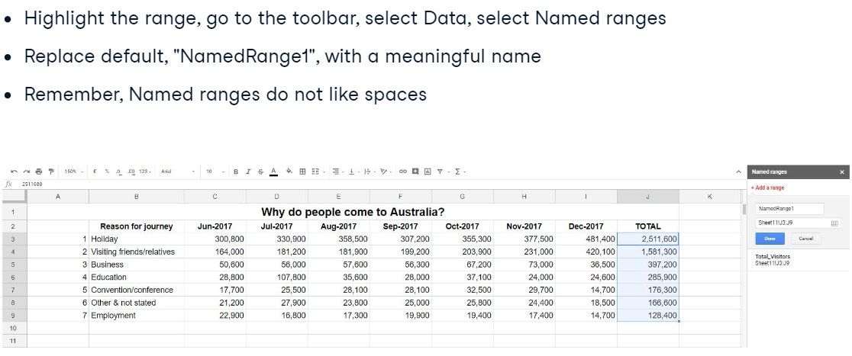

* Editing named ranges:

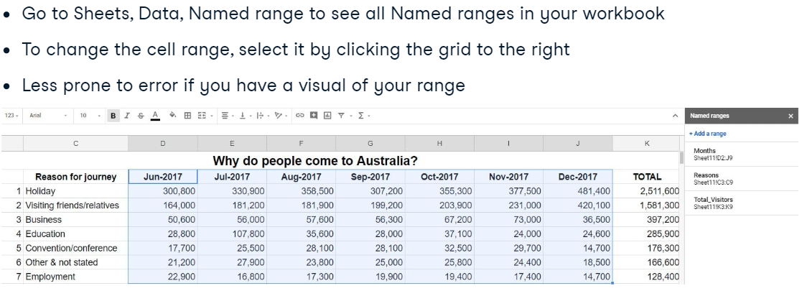

## Dashboard Controls

### Data validation

* Data Validation process:

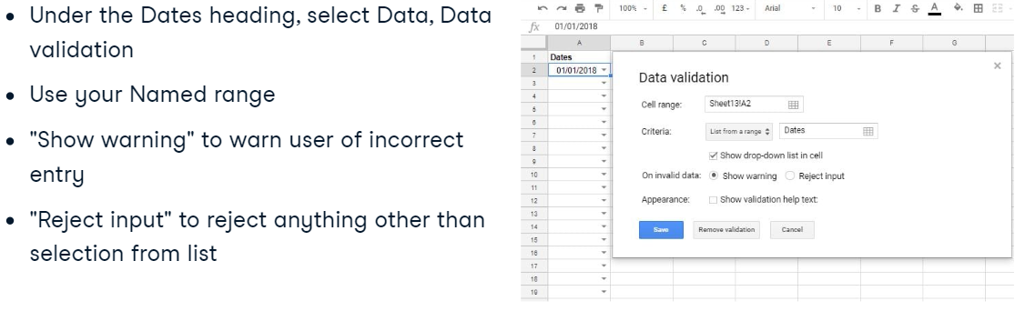

### Formatting your line chart

* Chart and edit titles:

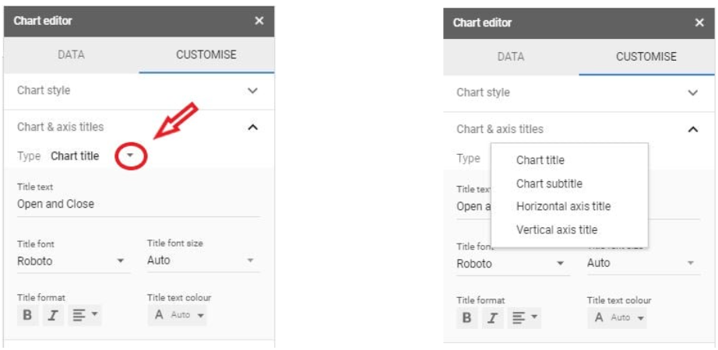

* Error bars, data labels, and trendlines:

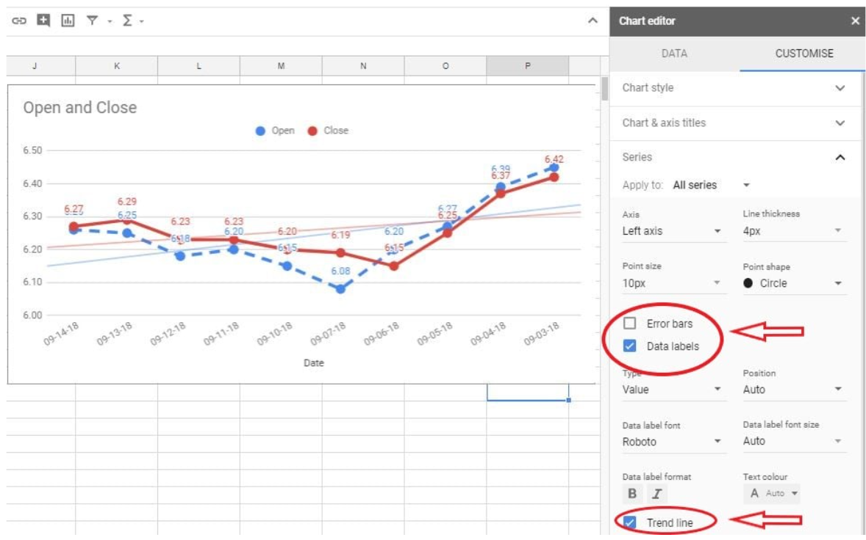

## Other Charts for Your Dashboard

### Candlestick charts

* Why do we use it:

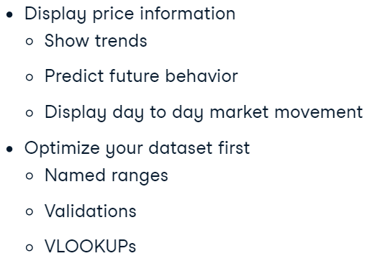

### Sparkline charts within a cell

* Creating sparkline and formatting it:

=SPARKLINE(G17:G26, {"charttype", "column"; "color", "blue"})

## Conditional Formatting

* Rules for formatiing:

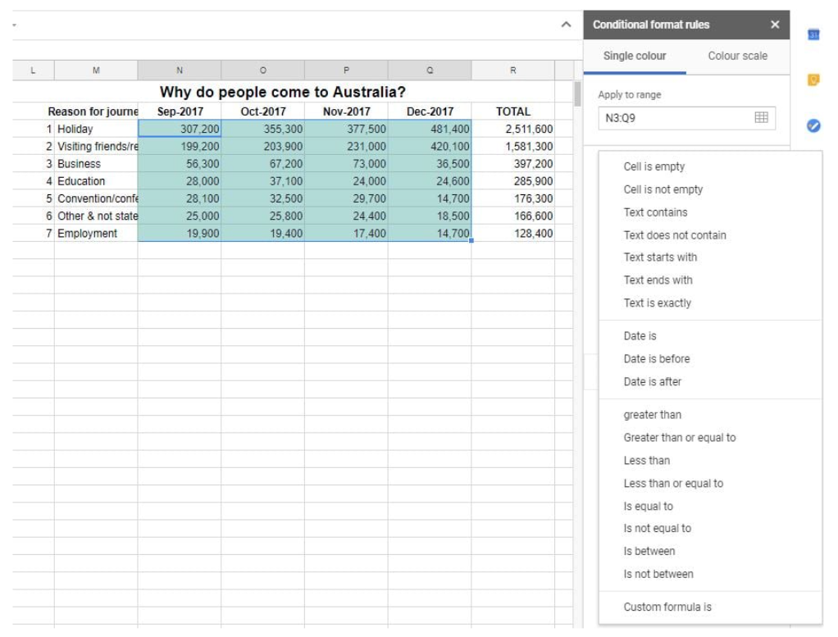

* Formatting for the whole row of data:

